Our Ref: _______________ Your Ref: ________________________ Date: __________________

Baptist Church

Baale Yaku Site Area, P. O. Box 644,

Ogbomoso, Oyo State. Tel. 07052425407

Email: [newsprinbaptistchurch@gmail.com](mailto:newsprinbaptistchurch@gmail.com)

Website: newspringbc.comze.com

NEW SPRING

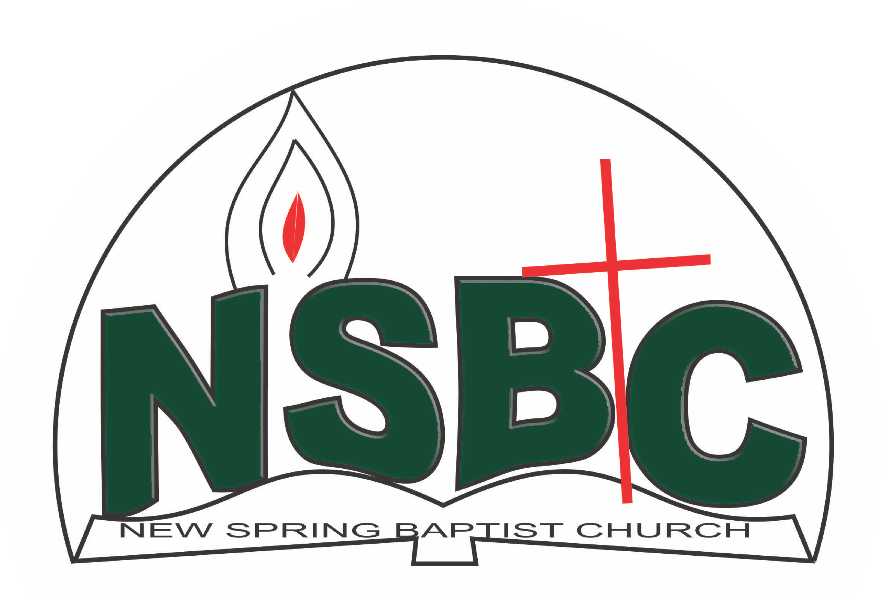

2 January 2022

Dear Mr. Victor Ayansola

Nomination to Serve as a Worker in the Church in 2022.

Calvary greetings in the precious name of our Lord and Saviour Jesus Christ. It is our pleasure to inform you that at the Church-in-Conference held on December 19, 2021; the Church ratified your nomination to serve in the following areas between January 1 and December 31, 2022:

1. Teacher, Sunday school under the Leadership of Dn Sunbo Olatubosun
2. President, Youth Fellowship
3. Member, Membership Committee under the Chairmanship of Mr. Johnson Olaniran
4. Member, Benevolence Committee under the Chairmanship of Dn. Dele Olatubosun
5. Member, Stewardship Committee under the Chairmanship of Mrs. Nia Olupona
6. Member, Nominating Committee under the Chairmanship of Dn. Dr. Ayinde Ezekiel
7. Member, Mission and Evangelism under the Chairmanship of Dn. Dr. Ayinde Ezekiel
8. Member, Visitation Committee under the Chairmanship of Mrs. Ruth Olanrewaju
9. Member, Intercessor Committee under the chairmanship of Mrs. Funke Oyekunle
10. Member, Church Council

Please refer to the table below for the key functions of each of these roles. Details can be found in the Church constitution. You are strongly encouraged to become familiar with the tasks as stated in the document. There will be an orientation of the Church workers on January 22, 2022 at 8:30 a.m. on the church premises. Please ensure you participate in this training.

“Now it is required that those who have been given a trust must prove faithful. I Corinthians 4:2”. May God find you faithful in the task He has assigned to you.

| Domain | Key function of Office, Department or Committee |
| --- | --- |
| Teacher, Sunday school | To provide support to the Church Pastor in the teaching ministry of the Church to ensure that members and regular worshippers are well grounded in the Scriptures. |
| Youth President | To provide support to the Church Pastor in equipping the youth of the Church for Christ-like life style and responsible adulthood |
| Membership Committee | The committee is responsible for the overall management of the membership of the Church. |
| Benevolence Committee | The committee is responsible for the implementation of the benevolence policy of the Church. |
| Stewardship Committee | The committee is responsible for the overall management of the Church’s fiscal policy. |
| Nominating Committee | Shall coordinate the staffing of all Church leadership positions that are filled by volunteers |
| Mission & Evangelism | The committee is responsible for the mobilization of Church members for soul winning activities. |
| Visitation | Visit members and worshippers at home or special institutions with a view to encouraging them in their Christian walk and reporting on pertinent issues that may require Church intervention and appropriate action |
| Intercessor Committee | The committee is responsible for standing in the gap on behalf of the Church and her members |
| Church Council | The Church Council is the governing body of the Church whose membership, under the leadership of the Holy Spirit, holds one another mutually accountable with respect and love and sees to the smooth running of the Church. |
|  |  |

Thank you for accepting to serve in this Church.

Yours in His service

Olusayo Okediji Blessed Agboola

Church Secretary Chairman, Nominating Committee